So i’ve conducted some research into similar rhythm games that would are able to look at for our new idea of a rhythm game.

Now, with our idea being a ‘duel’ type rhythm game where a single line splits into two lanes in which players compete is somewhat unique to this genre. The closest thing i found was from the new Switch release, Super Beats Sports.

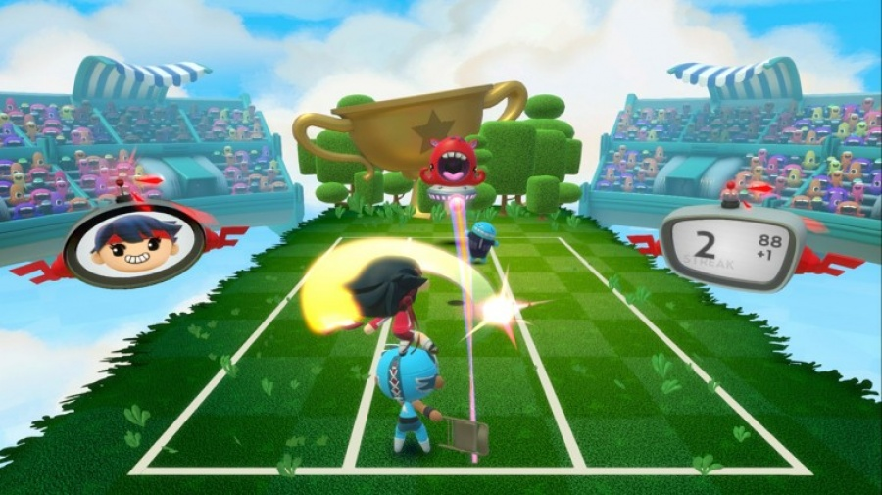

(http://www.nintendolife.com/reviews/switch-eshop/super_beat_sports)

As you can see, the similarities are slim but we can still compare. In super beats sports there is three lanes in which players swap lanes to hit the beats (represented as balls) that match their colour. The main difference between this game and our idea, Tapdat, is that super beats sports is a co-op rhythm game where if one player misses a beat, both are penalised. We look past this as my main interest from this game is the 3 lane system and how the player must react to get to the correct lane for their beat. I am thinking about the possibility of throwing the player an ‘oddball’ in Tapdat in which the players must swap their lanes for a single, or multiple beats to get their points.

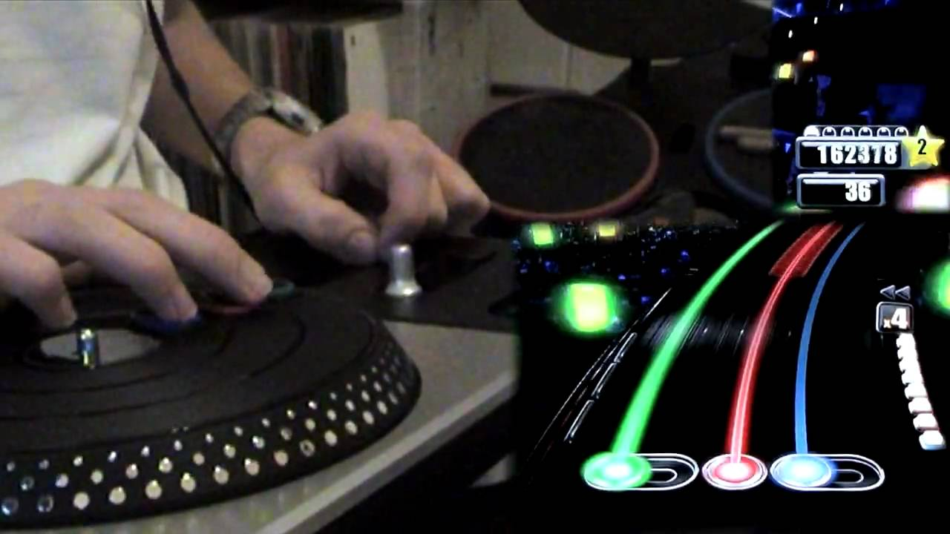

(<https://www.youtube.com/watch?v=B0Fep2UDBbo>)

Now, I looked at DJ Hero as well and I know that we was trying to avoid DJ hero and guitar hero due to their monotonous take on the rhythm genre, but I really like the UI of this game. The way the tracks and beats bend just makes it a bit more visually pleasing rather than a flat and boring design. I’d really like to take on this kind of perspective for our game.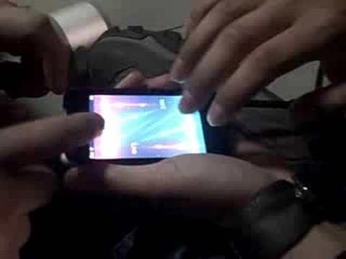

Now after an incredibly long time looking into rhythm games I seem to have found one that is perfect for the brief and is similar to our original idea, Soundsystem showdown. Tap Tap Revenge is a multiplayer rhythm game and as you can see from the picture included this game is a real time multiplayer rhythm game in which two players take one side of a phone each for their lane and hit their beats. I believe the players in this picture are using an old Iphone 3G and this might put to rest our problem that having both players playing at the same time wouldn't work on a small mobile.

The only problem I see with this game is the fact that each player only uses a single lane each, I believe this to be too easy for the players and therefore not that enjoyable to player. The only way i can see this is to boost the note speed to insane levels but this may give us a challenge to balance this whilst sticking with the one tap only requirement of the brief.